Name:_______________________

KS3 Homework Booklet

Homework 1 | Key science terms 1 | Due date: | Completed?
Homework 2 | Maths in science homework 1 | Due date: | Completed?
Homework 3 | Practical Homework: Crater Impacts on Mars | Due date: | Completed?
Homework 4 | Key science terms 2 | Due date: | Completed?
Homework 5 | Maths in science homework 2 | Due date: | Completed?
Homework 6 | Practical Homework: Egg-tastic | Due date: | Completed?
Homework 7 | Key science terms 3 | Due date: | Completed?
Homework 8 | Maths in science 3 | Due date: | Completed?
Homework 9 | Practical Homework – Choc-tastic | Due date: | Completed?
Homework 10 | Key science terms 4 | Due date: | Completed?
Homework 11 | Maths in science 4 | Due date: | Completed?
Homework 12 | Keyword science 5 | Due date: | Completed?
Homework 1 - Key Science Terms 1
Learn the spelling of the key term and their definition. Use each of the terms in a sentence and bring this to your lesson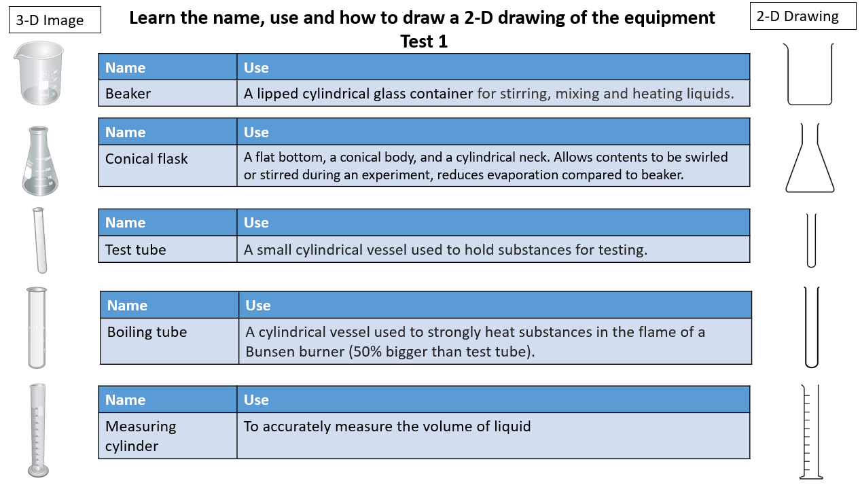

History Homework Task Term 5

Homework 2 – Maths in Science 1
Complete the questions on the maths in science homework sheet 1

Homework 3 – Practical Science Homework - Crater Impacts on Mars:
Some Martian craters have central peaks; some are surrounded by material that has been ejected, called the ejecta blanket. Impact craters are interesting to study and provide insights into the age and geology of a planet’s surface. Predict what patterns might be produced if meteorites had landed onto a wet Martian surface.
Prepare a mix of soil and water. The mud should be sufficiently sloppy to eject mud splats when the mass is dropped! Place the mud in the middle of a large sheet of paper or card. Drop a variety of ‘meteorites’ (e.g. marbles/rubber balls/stones) into the mud from different heights and observe the patterns produced. Measure the distance travelled by the mud ejected on impact. Record your results in a suitable table.
In your homework report you should include:
  - State the independent, dependent and control variables of the experiment.
  - A bullet point method that you used
  - Table of results
  - Conclusion (describe how the independent variable affected the dependent)

Homework 4 - Key Science Terms 2
Learn the spelling of the key term and their definition. Use each of the terms in a sentence and bring this to your lesson
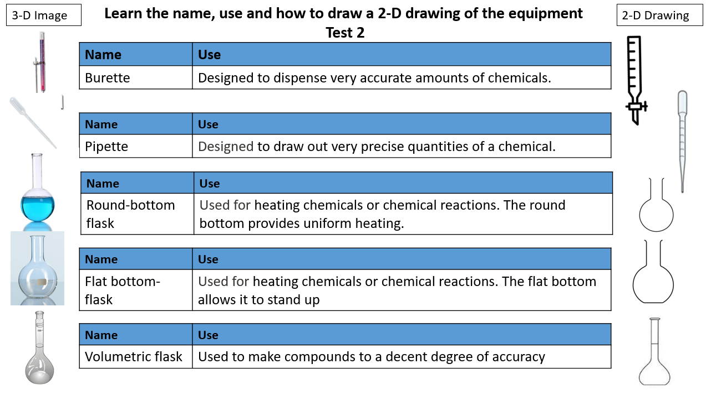

Homework 5 – Maths in Science 2
Complete the questions on the maths in science homework sheet 2

Homework 6 – Practical Science Homework Egg-tastic!
Experiment 1
- Fill two glasses with water. Add four tablespoons of salt into one of them and stir until dissolved.
- Add an egg to each glass and note what happens to their location in the glass.
Produce a mini-science report:
  - State your method (what you did)
  - Draw/take a photo of your results
  - Suggest a reason for the difference.

Experiment 2
Take three eggs and place them in vinegar overnight to remove the shell.
Pat dry and measure the mass of each egg. (if you don’t have mass scale, leave this stage)
In three containers add equal volumes of water. Label 1,2 and 3. Container 1 will be just water, container 2 add 2 tablespoons of sugar, container 3 add 8 tablespoons of sugar. Stir to dissolve.
Place one egg in each container and leave for 24 hours.
Remove and measure new mass, or describe how each looks in comparison to the other eggs.
Produce a mini-science report:
- State the independent, dependent and control variables of the experiment.
- State your results - this could be a table of masses and/or photos/description of each egg from each solution
- Conclusion - describe how the independent variable affected the dependent.
- Challenge – research and explain the results you have found.

Homework 7 - Key Science Terms 3
Learn the spelling of the key term and their definition. Use each of the terms in a sentence and bring this to your lesson
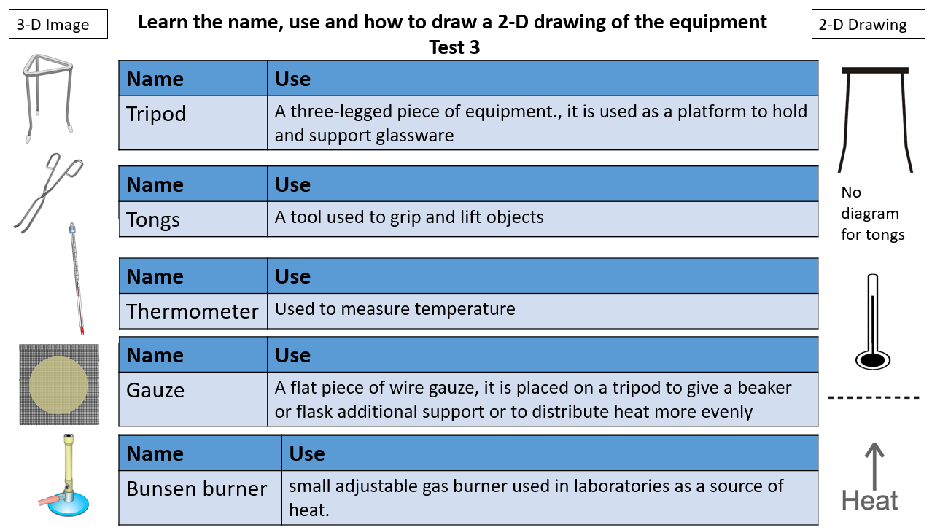

Homework 8 – Maths in Science 3
Complete the questions on the maths in science homework sheet 3

Homework 9 – Practical Science Homework- Choc-tastic
- Take three different types of chocolate (e.g. milk, dark and white)
- Try and ensure you have an equal size chocolate squares (you could measure the mass if you have a mass scale at home)
- Place one square in three different foil cake cases (e.g. mince pie cases)
- Place the foil cases in a plastic container/baking tray/large mixing bowl
- Add boiled water that has cooled down, not higher than approximately 50°C (leave for 10 mins after boiling)
- Time how long each chocolate takes to fully melt.
- You may need to stir to be sure it is melted.
In your homework report you should include:
  - State the independent, dependent and control variables of the experiment.
  - State any changes to the method that you used, if it was the same, just write ‘stated method’
  - Table of results - this could include photos of your experiment
  - Conclusion - describe how the independent variable affected the dependent

Homework 10 - Key Science Terms 4
Learn the spelling of the key term and their definition. Use each of the terms in a sentence and bring this to your lesson
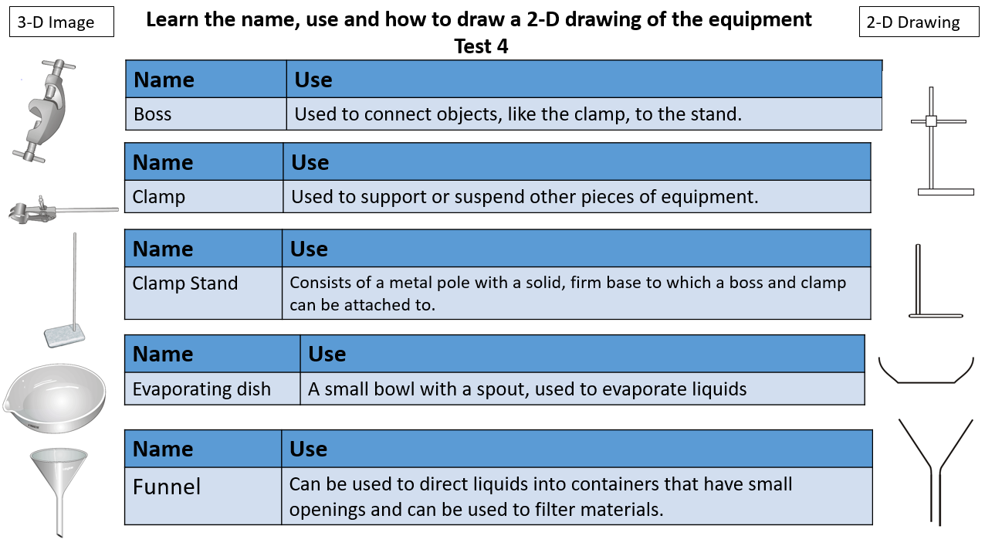

Homework 11 – Maths in Science 4
Complete the questions on the maths in science homework sheet 2

Homework 10 - Key Science Terms 5
Learn the spelling of the key term and their definition. Use each of the terms in a sentence and bring this to your lesson
Term | Definition
Variable | These are physical, chemical or biological quantities or characteristics.
Categoric variables | have values that are labels
Continuous variables | can have values (called a quantity) that can be given a magnitude either by counting or by measurement
Control variable | A variable which may, in addition to the independent variable, affect the outcome of the investigation and therefore has to be kept constant or at least monitored.
Dependent variable | The variable of which the value is measured for each and every change in the independent variable.
Independent variable | The variable for which values are changed

Homework 2 – Maths in Science 1
Complete the questions on the maths in science homework sheet 1

