Hockey
Work Booklet
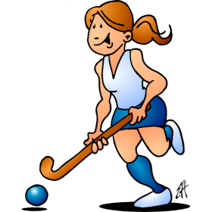

Hockey Teaching Points
Using the knowledge that you have gained from lessons and information you can find on the internet complete this teaching skills card to evaluate your own ability. You need to break down the skill into small chunks and different elements you need to check for.
Dribbling
Step | Can you …. | Self-Assessment |  |  | How can I improve?
1 | I can use the correct grip
2 | I keep a straight back, bend at the knees and am able to look up when dribbling
3 | I can dribble with the ball whilst moving slowly and keep it “glued” to the end of my stick.
4 | I can increase my speed by “tapping” the ball in front of me a short distance whilst maintaining control
5 | I can use the Indian dribble in practices.
6 | I can use the Indian dribble in match play.

Push Pass
Step | Can you....... | Self-Assessment |  |  | How can I improve?
1 | I can use the correct grip
2 | I keep a straight back, bend at the knees
3 | I keep the ball in contact with the stick from the start of the pass and follow through on release
4 | There is no audible knocking/slapping noise of the stick on ball
5 | I can apply power to my pass to move the ball over short and moderate distances

Dribbling
Step | Can you …. | Self-Assessment |  |  | How can I improve?
1 | I can use the correct grip
2 | I keep a straight back, bend at the knees and am able to look up when dribbling
3 | I can dribble with the ball whilst moving slowly and keep it “glued” to the end of my stick.
4 | I can increase my speed by “tapping” the ball in front of me a short distance whilst maintaining control
5 | I can use the Indian dribble in practices.
6 | I can use the Indian dribble in match play.

Rules of Hockey
Name 10 different rules for hockey, using information that you have learnt in lesson or information you have found on the internet.
https://www.playquicksticks.co.uk/how-to-play/rules-of-quicksticks/
https://www.englandhockey.co.uk/page.asp?section=1146&sectionTitle=Rules+of+Hockey
Rule
1
2
3
4
5
6
7
8
9
10

Research information about the female hockey England team and about their Rio 2016 Olympics success and write 5 key facts about them.
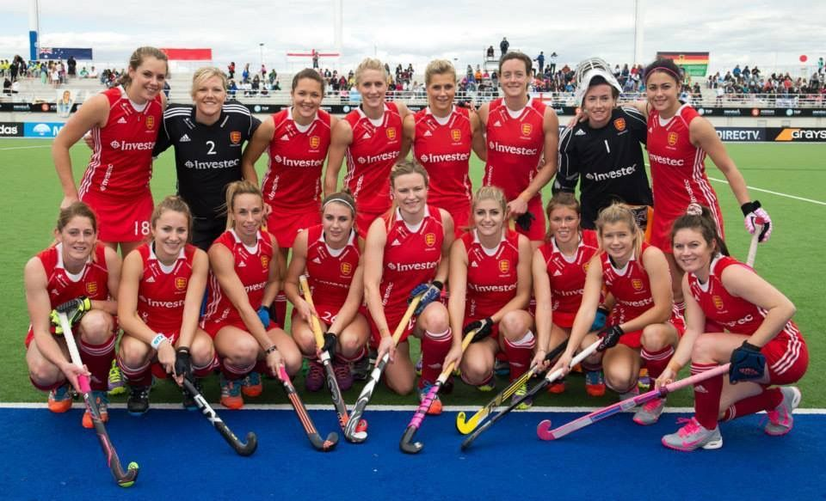

Research some more information online:-
https://www.youtube.com/watch?v=mEywEHcrRAU
https://www.youtube.com/watch?v=ZaiyfEvHRuA
http://www.englandhockey.co.uk/playerint.asp?section=44&sectionTitle=Current+International+Players
https://www.standard.co.uk/sport/women-s-hockey-world-cup-2018-england-squad-guide-for-london-a3892646.html

Write five key facts about the Women’s hockey team

1.

2.

3.

4.

5.

Self regulation
This term you have had a focus on improving the Montsaye’ s value of Resilience. You have done this by learning about developing self-regulation. Below is what is expected from a Year 7 student in relation to self-regulation – Take time to reflect and give an example of how you have demonstrated each of these in your Hockey lessons this term.

Example of self regulation | Example you have demonstrate in hockey
is able to maintain educational focus during all activities.

Demonstration of excellent sportsmanship behaviour

Is able to take on board constructive criticism

Is highly competitive but also considerate to others in competition

Is gracious when winning or in defeat on most occasions

If you would like to take part in extra-curricular activities within the PE department – please see our timetable of activities below.
