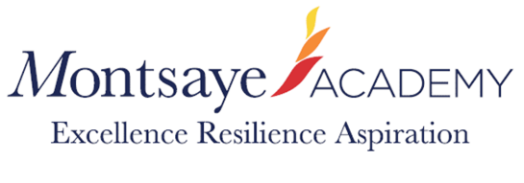
Risk Assessment Summer Term 2021

Masks usage as before the holiday. Compulsory on buses for pupils.
All movement and changes below are limited to and within POD groupings therefore minimising the Risk of transmission.
Year 7 will be moving between lessons within the POD- as a step up to the movement they will experience in September
Year 8 will be using the changing rooms for PE (cleaning schedule identified between classes). This is to prepare them for next year where we will resume normal pattern of changing for PE lessons.
Year 8 entry and exit to the year 8 POD changed to accommodate building works in Science- English/Library and through to Maths stairs.
Year 9 lunch venue change to the Café at lunchtimes and toilets in Science to be used.
Year 10 have moved POD to technology to accommodate the building works in Science.
Year 10 lunch venue has moved to the Restaurant.
Year 10/12 trial examinations will be conducted this term, ensuring that all pupils have a fixed seat for the duration of the examination period.
New Fire evacuation plan for Science developed as below

In the event of a suspected case of Covid the isolation space for close contacts will be either S8 (whilst still available) or the covered way by reception.
All other measures in the RA will remain the same.

