Governing Body Member Profiles for website December 2019
Sarah Austin-Clark  Community Governor  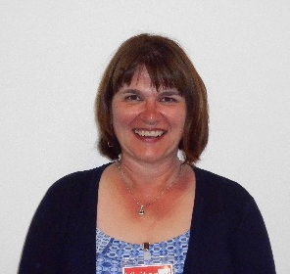 | Sarah Austin-Clark is a probate lawyer specialising in wills, trusts, charities and administering estates, with experience of managing a team. She has accounting and auditing knowledge and skills.  She has been a local Sunday school teacher and member of the committee for Rothwell Twinning Association.  She believes that in order for children to learn they need to be happy and have good quality teaching. She is passionate about helping Montsaye improve its outcomes to provide the opportunity for children to be able to learn and develop their skills at their local school.
Bradley Fox | Bradley Fox is the current President at Nottingham Trent Students’ Union, leading on strategy, governance and the relationship with Nottingham Trent University, Nottingham City Council, The University of Nottingham Students’ Union and The National Union of Students. In this role he represents the views of over 32,000 students, ensuring that they have the optimum university experience. He has experience of governance, currently sitting on the Board of Governors at Nottingham Trent University.  He is from Desborough and completed both his GCSEs and A Levels at Montsaye from 2007 – 2014 before beginning his degree at Nottingham Trent University. He has most recently graduated from there with a Masters in Branding and Advertising. Bradley is particularly interested in helping students and the school bridge the gap from A-Level to Post-18 education.
Meena Gabbi  Principal  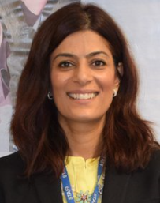 | Mrs Gabbi started her teaching career in Coventry as an English teacher and this then quickly developed and she moved to a head of department and then onto a senior leadership team. She has a range of school improvement experience and has worked on a number of city wide initiatives including functional skills and working as part of a collaborative headteachers groups on pupil premium strategy and also in the formation of Early Help hubs in the north of Coventry.  Mrs Gabbi has been in education for over 20 years and has an overwhelming passion for improving the life chances of young people. She is committed to ensuring that the children at Montsaye have a good quality of education and leave the academy with the best start in life.
Angela Lloyd  Chair  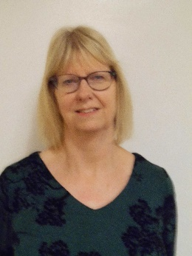 | Angela Lloyd has an extensive range of secondary school teaching and management experience. From teaching geography to setting up a new expressive arts faculty and monitoring rapid improvement plans, her education background gives her excellent grounding to be a school governor.  She is an active member of St. Giles church, Desborough and is looking forward to supporting the local community by making a difference to outcomes for young people.

Adrian Oram  Staff Governor | Adrian Oram has worked at Montsaye in the data office for five years so is very well-placed to advise the governing body on past and future performance.  With previous roles in the photographic industry, he has experience of overseeing complex projects and budgets.  He has lived in the community for twenty years and has 3 secondary age children. He is committed to shaping the strategic policy and vision of the school.
Ryan Thompson  Parent Governor, Vice Chair | Ryan Thompson has much previous experience as a governor, having held a place on Havelock’s governing body for 7 years. In this post, he held various positions, including Vice Chair and Chair of Finance Committee.  He is looking forward to having the opportunity to support and challenge the school to aid Montsaye in its continued improvement.
Tim Shea  Staff Governor | Tim Shea heads the drama department at Montsaye, where he has been teaching for nearly 3 years.  He has previously been on his children’s primary school governing body, supporting its leadership team to move the school from Requires Improvement to Good. He gained experience there of being Vice Chair and Chair of the Learning and Achievement committee.  Having seen Montsaye’s journey from Special Measures to Good, he is keen to be part of the new governing team that moves the school onwards as it faces new challenges including the new Ofsted framework amidst political uncertainty.

