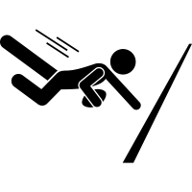
Rugby Union
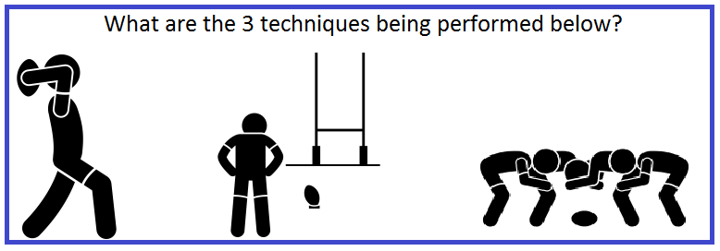
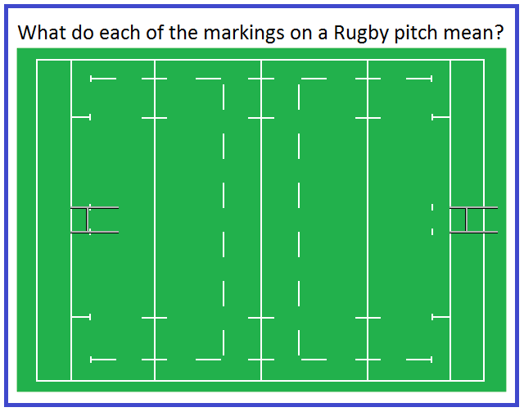

Excellence: You have learnt the following skills in rugby. Choose one skill and describe the correct technique required to perform the skill.
Ball handling and carrying skills, Passing technique off both sides, beating opponents using change of pace/direction and Try scoring- grounding the ball with downward pressure

Challenge 1  Find out what a ‘grubber kick’ is and attempt this over 5/8/10m  +Attempt with non-dominant foot  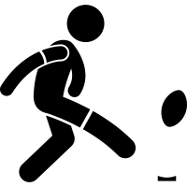 | Challenge 2  Perform 30 seconds of lateral passing with a partner in both directions (left & right)  + Increase the distance  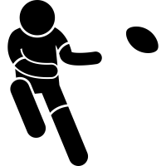
Challenge 3  Practise your try scoring technique. You must apply downward pressure on the ball  +Research Chris Ashton’s famous try scoring technique on YouTube | Challenge 4  Dustbin Drop Goal  Research how to perform a drop goal and attempt this from 5m.  +Increase distance to 7/9m and attempt with non-dominant foot  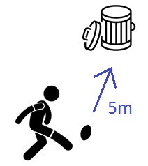
Challenge 5  Identify who these famous England payers are and what position they play. Look up footage of them on YouTube | Challenge 6  Get pictured completing any challenge and tweet @montsayepe  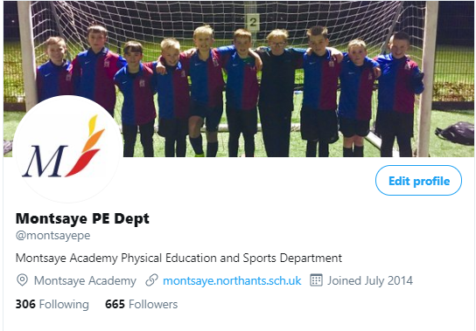
Rugby Union Challenges
Teamwork
This term you have had a focus on improving the Montsaye’ s value of Aspiration. You have done this by learning about developing Teamwork. Below is what is expected from a Year 8 student in relation to teamwork skills. Take time to reflect and give an example of how you have demonstrated each of these in your Rugby lessons this term.
Example of Teamwork | Example when you have demonstrated this in Rugby
Give 2 examples of when you have demonstrated respect to a team mate, opposition player or referee during your rugby lessons.

Explain why in a team game such as rugby, it is important for excellent teamwork to be demonstrated.

Explain how verbal communication can improve teamwork and group success.

Using an example, explain what would happen to a team’s performance if communication was poor

Explain how non-verbal communication can improve teamwork and group success.

Using an example, explain what would happen to a team’s performance if non-verbal communication was poor.

If you would like to take part in extra-curricular activities within the PE department – please see our timetable of activities below.
